1. 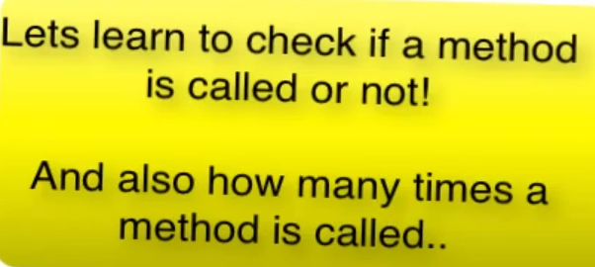
2. Let’s try to understand what we want to do.
3. 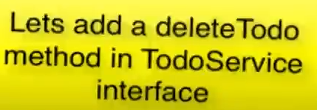
4. 
5. Graphical user interface

   Description automatically generated with medium confidence
6. Text

   Description automatically generated with medium confidence
7. A picture containing application

   Description automatically generated
8. A picture containing text

   Description automatically generated
9. If you want to verify if a method is not called on a mock object.Text

   Description automatically generated
10. Verifying a specific times a method is called.  
    Graphical user interface, text

    Description automatically generated
11. Verifying at least once a method is called.  
    Text

    Description automatically generated with low confidence
12. Text

    Description automatically generated